

Team Members:

Dimapilis, Joshua C.

Elizondo, Kimberly Mae B.

Urquiza, Trixia Marie A.

**IT – 111  
  
April 3, 2015**

ASND - LCMAM

**AngSalitaNgDiyos.com   
The Lectors and Commentators Ministry for the Archdiocese of Manila**

Ang salita ng diyos.com  
Liturgical Calendar

User Manual v1.0

**Table of Contents**

I. Introduction 2

II. User Groups 2

III. Functionalities 2

**a.** **System / Site Registration and Login** 2

i. System Registration 3

ii. System Login 5

**b.** **Calendar Display** 7

i. Calendar View 7

ii. Event Display 8

1. Event Hover 10

2. Event Popup 11

3. Event Reading Link 11

iii. Event View 12

**c.** **Administrator Privileges** 16

i. Event Determinant 16

ii. Events 16

iii. Solemnities, Feasts and Memorials 16

iv. Sunday and Weekday Readings 17

v. Users 17

* **Introduction**

AngSalitaNgDiyos.com, is an online Catholic Liturgical site that accommodates the online audience and their needs, spiritually and information - wise.

Ideally, the ALS Calendar is a calendar structure that can display the Lectionary Cycles and Liturgical Feasts within a certain year. The proposed liturgical calendar of the team, comes with a tool that allows the clients to update certain information available in the calendar.

* **User Groups**

The client is responsible in managing the said tool, accompanied by the calendar. Throughout the project, the presumable stakeholders that the proponents considered were the following:

* **Client Site Administrators** (Clients’ IT people, )
* **Calendar Viewers** (Priests, Lectors, Commentators)

Mainly, this user manual is directed to the **Client Site Administrators,** because, they are responsible for the maintenance of the data that is rendered in the ALS Calendar. The **Calendar Viewers**’ main concern includes only that of viewing and listening to the calendar. Considerably, the site will also be hosted in the *AngSalitaNgDiyos.com*, site (created by one of our advisers) therefore, the site will be visible to those who can access the said site.

* **Functionalities**

The ALS Calendar Tool, has 2 basic functions, and 1 minor function. The basic functions include the **Calendar Display, and the Administrator Privileges,** and the minor function refers to the **System / Site Registration and Login.** This section of the User manual, aims to enlighten the user as to how they will be able to handle, manage and use the data within the calendar database, which are reflected in the calendar tool.

* 1. **System / Site Registration and Login**

This section discusses the instructions to be followed by the users of the system upon registration and signup. The following steps are all done, under the assumption that the user is already has access to the site. This is done to provide access to the Client Site Administrator. The system may be deemed as *lenient* in providing access, this is because, it is ensured that the only users who will gain overall access to the tool are the Client Site Administrators.

* + 1. System Registration

Here is the ALS Calendar Tool Navigation Bar:



Figure 1.0 **ALS Calendar Tool Nav Bar**

* Step 1: Administrator should click the **Signup button** in the Navigation bar.



Figure 1.1 **Signup Button**

* Step 2: The administrator is then redirected to the **Signup page**. This is how the Signup page looks like:

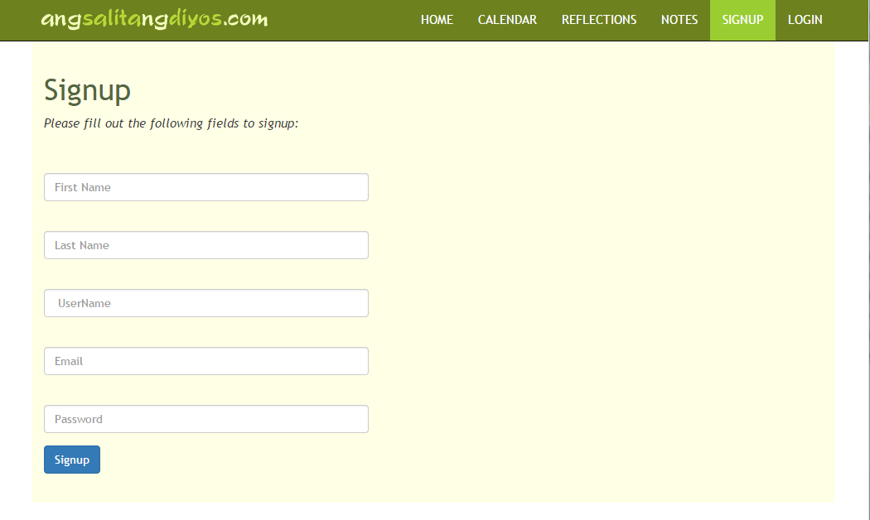

Figure 1.2 **ALS Signup Page**

* Step 3: Administrator is then expected to fill out the certain fields, *this is done purely for data storage,* and for *provision of* access privileges.

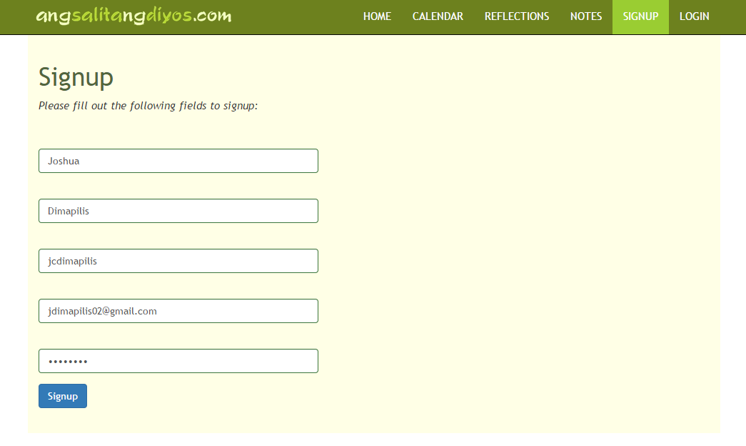

Figure 1.3 **ALS Signup Page with Client Admin Information**

* Step 4: After filling out the information, user should then click the Signup button.



Figure 1.4 **Signup Submit Button**

* Step 5: Administrator is given access to various processes available within the site. It can be seen below that the Navigation Bar has also changed.

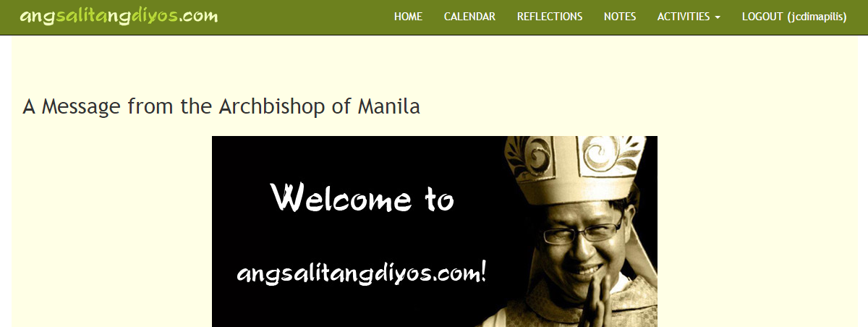

Figure 1.5 **Navigation Bar for logged in Administrator**

* Step 6: Administrator is then redirected to the home page, and is automatically logged in.

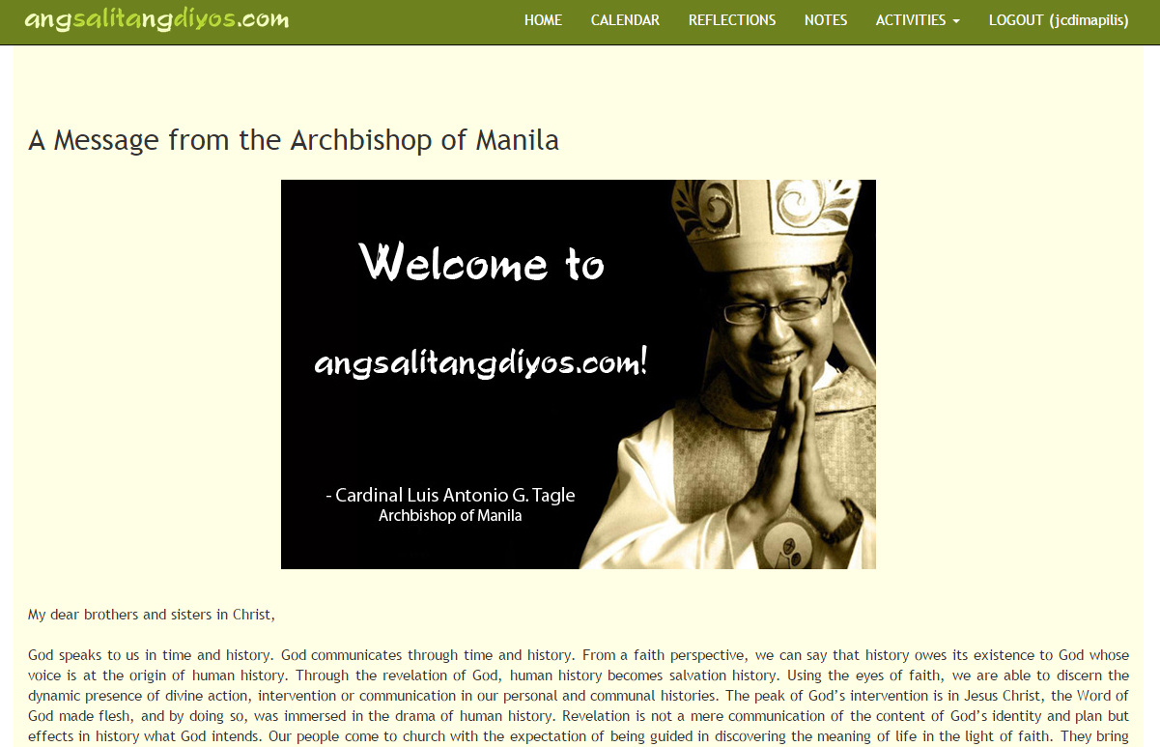

Figure 1.6 **Home Screen / Splash Screen after signing up and logging in**

* + 1. System Login

In this section, we are assuming that the administrator is no longer logged in, and that the admin is about to login. The only pages available for a user that is not logged in is the home page / the splash screen. Other than that, the user is required to log in first to be able to access other pages. It is **important to note,** that whatever page the user clicks (between Calendar, Reflections, and Notes) before logging in, this will be the page that they will be redirected to after they input the right username and password. ***(In this example, the user clicked the Notes section)***

* Step 1: User should click the **Login button** located in the Navigation Bar.

 

Figure 1.7 **Login Button, Unclicked and Clicked**

* Step 2: User will be redirected to the login page.

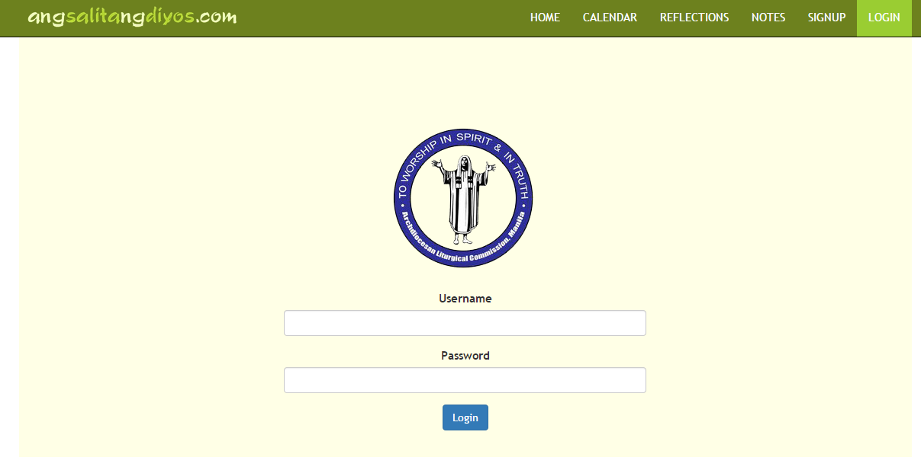

Figure 1.8 **Login Screen**

* Step 3: Administrator should then enter his / her username and password.

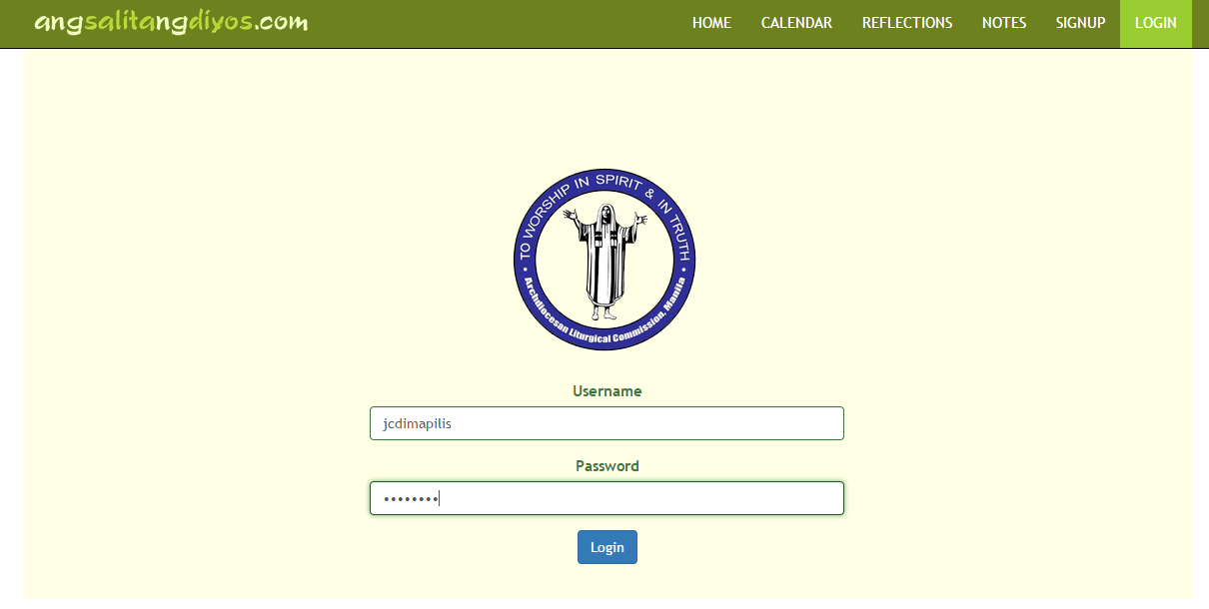 Figure 1.9 **ALS Login Page with Client Admin username and password**

* Step 4: Administrator should click the Login button



Figure 2.0 **ALS Login Button**

* Step 5: Administrator is then redirected to the last page they visited, wherein they were prompted to login.

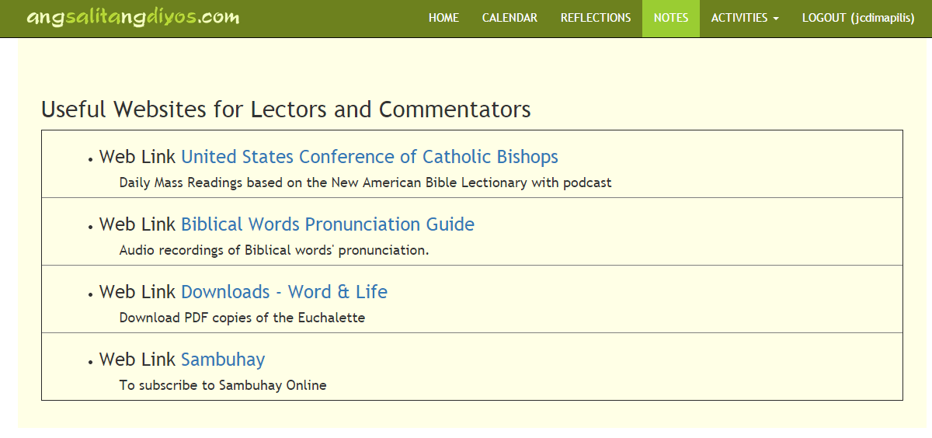 Figure 2.1 **Administrator is redirected to the Notes Section** (page that prompted login)

* 1. **Calendar Display**

In the succeeding numbers, the steps and the instructions will be focused more on viewing the calendar and its functions. It is important to note that the succeeding processes assume that the administrator already has an account, and is already logged in.

* + 1. Calendar View
* Step 1: Administrator should click the **Calendar button** in the Nav bar.



Figure 2.2 **The Calendar Button** from the Nav bar

**NOTE:** The calendar is also among the pages that will only be visible if user is logged in. To view the calendar, ensure that the user is logged in.

* Step 2: After the Calendar button is clicked, the administrator is brought to the calendar page. This is how the calendar page looks like:

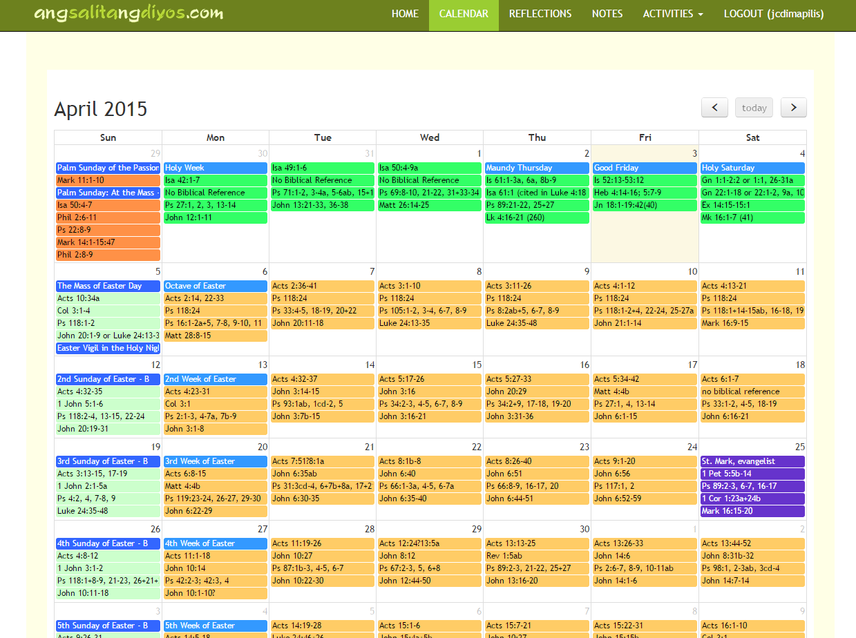

Figure 2.2 **The Calendar Button** from the Nav bar

**NOTE:** To navigate within the years of the calendar, admin may click the following buttons:

Figure 2.3 **The Arrow and Today buttons** for calendar navigation

* The **Left Arrow button** brings you to the previous month.
* The **Today button** brings you to the month that displays the date today.
* The **Right Arrow button** brings you to the next month.
* Step 3: Admin should click the **left arrow button** to go back to the previous month. (e.g. April -> March)

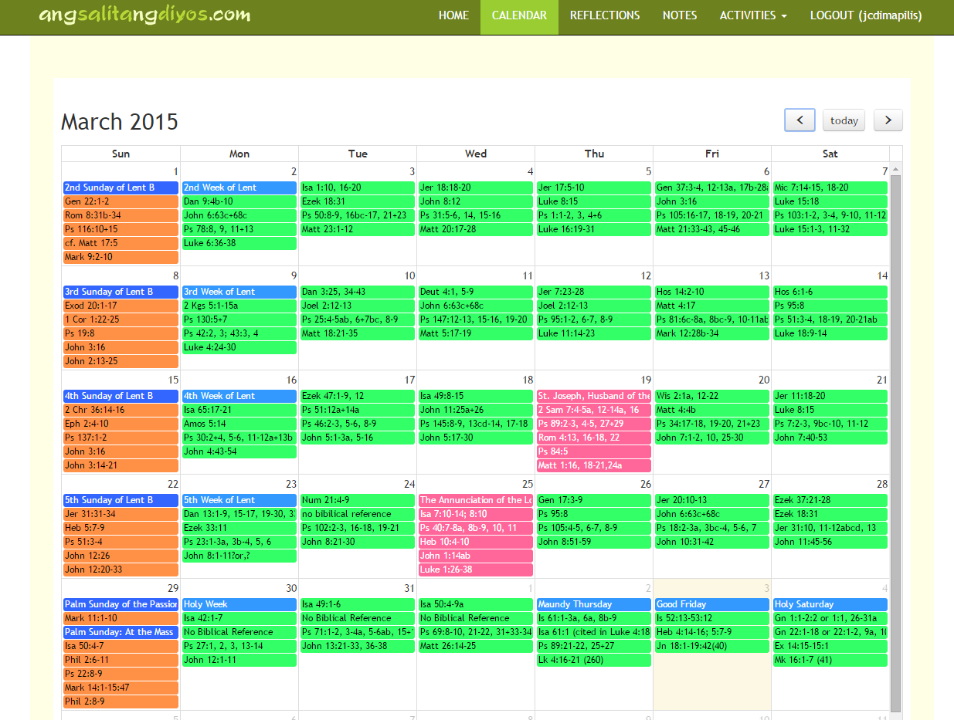

Figure 2.4 **The Calendar shifting to the Previous Month**

* Step 4: Admin should click the **right arrow button, *twice***to view the month after the first month that the administrator was viewing. (e.g. March -> May)

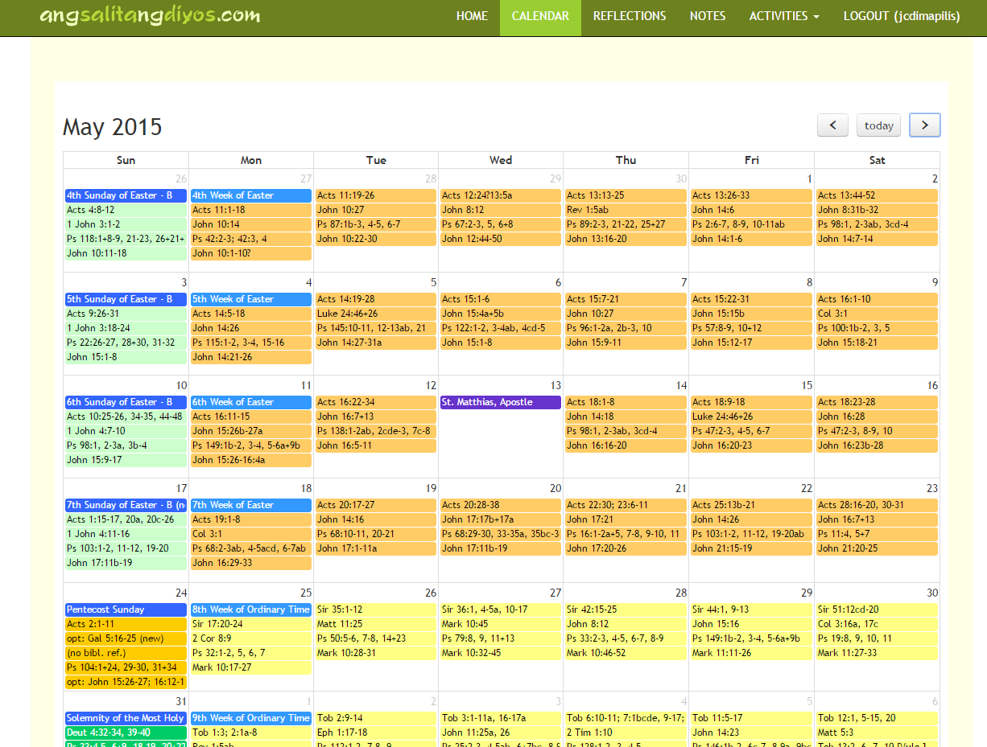

Figure 2.5 **The Calendar shifting to the Next, Next Month (May)**

* Step 5: Admin should click the **today button,** and the administrator will be redirected back to the month of today’s date.

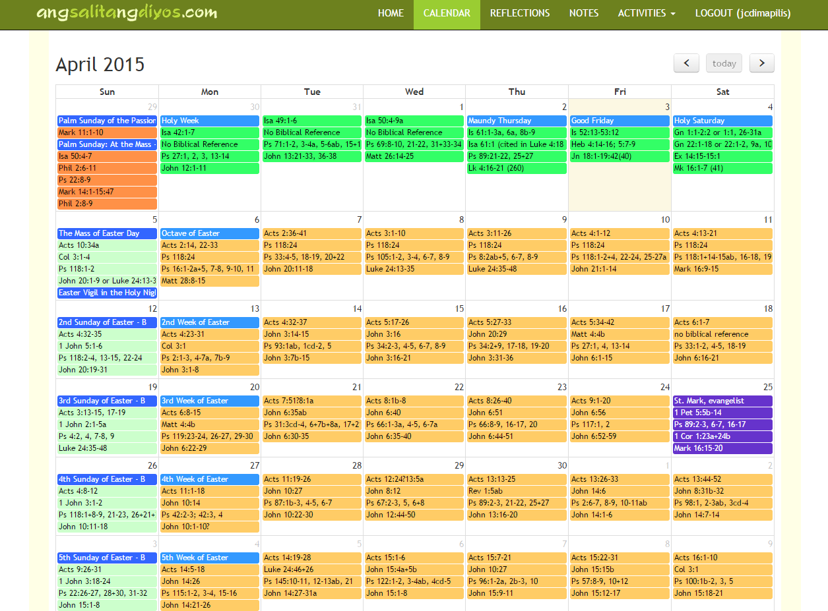

Figure 2.6 **Admin is redirected to the month of today’s date (April 3)**

* + 1. Event Display

This section discusses the various functionalities that a single event may possess. This section will explain the various effects of hovering, clicking and viewing each event that is rendered in the calendar.

* + - * Event Tooltip

**NOTE:** The event tooltip may only be triggered by hovering on a said event. It is important to note, that every colored line (composed of text) in every date is technically, considered a single event (even though they belong to one date).

Step: Hover on a date’s event header. (e.g. 1st Week of Ordinary Time)

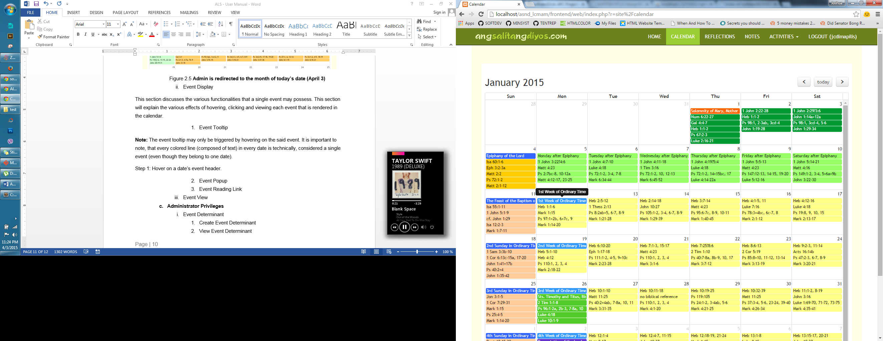 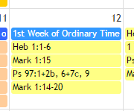

Figure 2.7 **Difference of hovered event headers**

* + - * Event Popup

**NOTE:** The event popup may only be triggered by clicking on a said event. This displays the **reading type**, what **season** it belongs to and the **optional readings**, if there are any.

* Step: Click a date’s event header. (e.g. 1st Week of Ordinary Time)

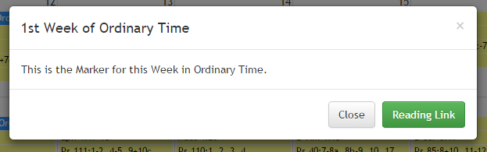

Figure 2.8 Event click triggers the said popup **for event header**

* Step: Click a date’s event reading. (e.g. Heb. 1:1-6)

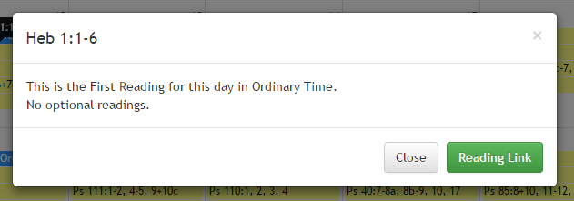

Figure 2.9 Event click triggers the said popup **for event reading**

* + - * Event Reading Link

**NOTE:** The Reading link, is available in all popups. For **event headers**, it may be ignored (it redirects to “/” or “home”), however, for event readings, by default it sends the user to “/” or “home”, unless it is edited in the CRUD section. (This will be explained in detail in the later part.)

The Reading Link supposedly redirects you to a desired **link (page / audio file).**

* Step 1: Click a date’s event reading. (e.g. Heb. 1:1-6)



Figure 3.0 Event click triggers the said popup **that contains the Reading Link**

* Step 2: If the event has a reading link, set in the database (edited via CRUD), then if it is clicked, it supposedly redirects you to a new file that shows the audio file / link’s page. Otherwise, it just redirects you to “/” or home.



Figure 3.1 **Reading Link** redirects administrator to Audio file / page in new tab

* + 1. Event View

This section may serve as a guide for the administrator to follow the coloring scheme of the said events plotted in the calendar. Even though the **season of the event** is displayed in its event popup, it might be helpful for the administrator to know what type of event each color represents.

* The following readings in **pine green,**  are Christmas weekdays / solemnities:

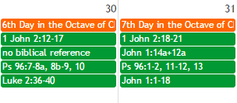 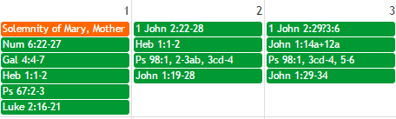

Figure 3.2 **Christmas Weekdays / Solemnities (in January and December)**

* The following readings in **chrome yellow** are special Sundays (some examples include Epiphany of the Lord, Pentecost Sunday, Octave of Christmas: Holy Family of Jesus)

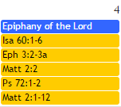 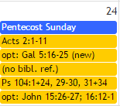 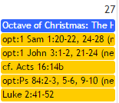

Figure 3.3 **Some Special Sundays**

* The following readings in **yellow green** are days after the Epiphany

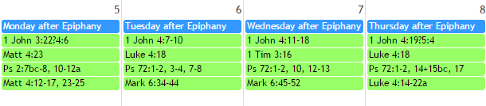

Figure 3.3 **Days After the Epiphany**

* The following readings in **peach** are Sundays in Ordinary Time

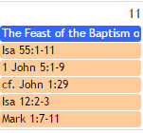 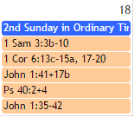

Figure 3.4 **Sundays in Ordinary Time**

* The following readings in **yellow** are Weekdays in Ordinary Time

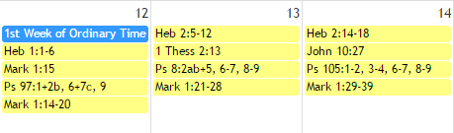

Figure 3.5 **Weekdays in Ordinary Time**

* The following readings in **bright green** are Memorials

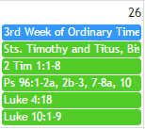

Figure 3.6 **Memorials**

* The following readings in **purple** are Feasts

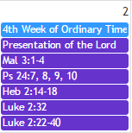

Figure 3.7 **Feasts**

* The following readings in **pink** are Solemnities

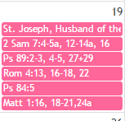

Figure 3.8 **Solemnities**

* The following readings in **bright orange** are Sundays of Lent

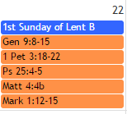 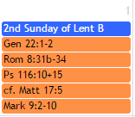

Figure 3.9 **Sundays of Lent**

* The following readings in **neon green** are Weekdays of Lent

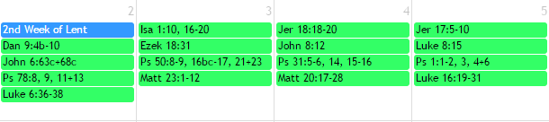

Figure 4.0 **Weekdays of Lent**

* The following readings in **blue green** are Sundays of Easter

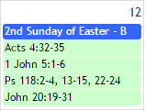 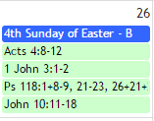

Figure 4.1 **Sundays of Easter**

* The following readings in **pale orange** are Weekdays of Easter

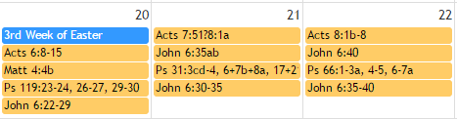

Figure 4.2 **Weekdays of Easter**

* The following readings in **mint green** are Special Solemnities (Trinity Sunday, Corpus Christi, Sacred Heart)

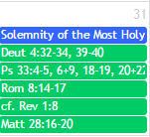 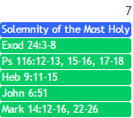 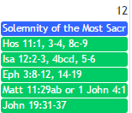

Figure 4.3 **Special Solemnities**

* The following readings in **vibrant green** are Sundays of Advent

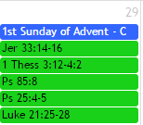 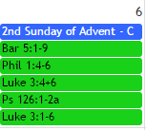

Figure 4.4 **Sundays of Advent**

* The following readings in **dark** **red and gold** are Weekdays of Advent

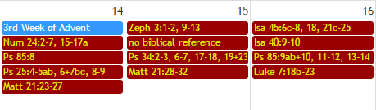

Figure 4.5 **Weekdays of Advent**

* 1. **Administrator Privileges**

The following are the CRUD processes that are allowed for the data entities of the system. The reason why creation and deletion of items are not allowed for some entities, is because adding dates would greatly affect the display and render of events in the calendar.

* + 1. Event Determinant

The Event determinant entity is responsible for plotting the main dependencies that most events / dates rely on to be placed on the liturgical calendar. Ideally, no changes were supposed to be made in these items, however, in times of conflict and when various changes must be done to adjust the yearly dates of the liturgical calendar, the administrator may edit / create here. However**, it is important to note** that updating items in the Event Determinant, will **greatly** impact how the calendar plots the dates *(which is why this makes / breaks the calendar* events).

* + - * Create Event Determinant
* Step 1: In the nav bar, admin should click the **Activities dropdown button**



Figure 4.6 **Activities Dropdown Button**

* Step 2: In the dropdown, admin should choose Event Determinant.

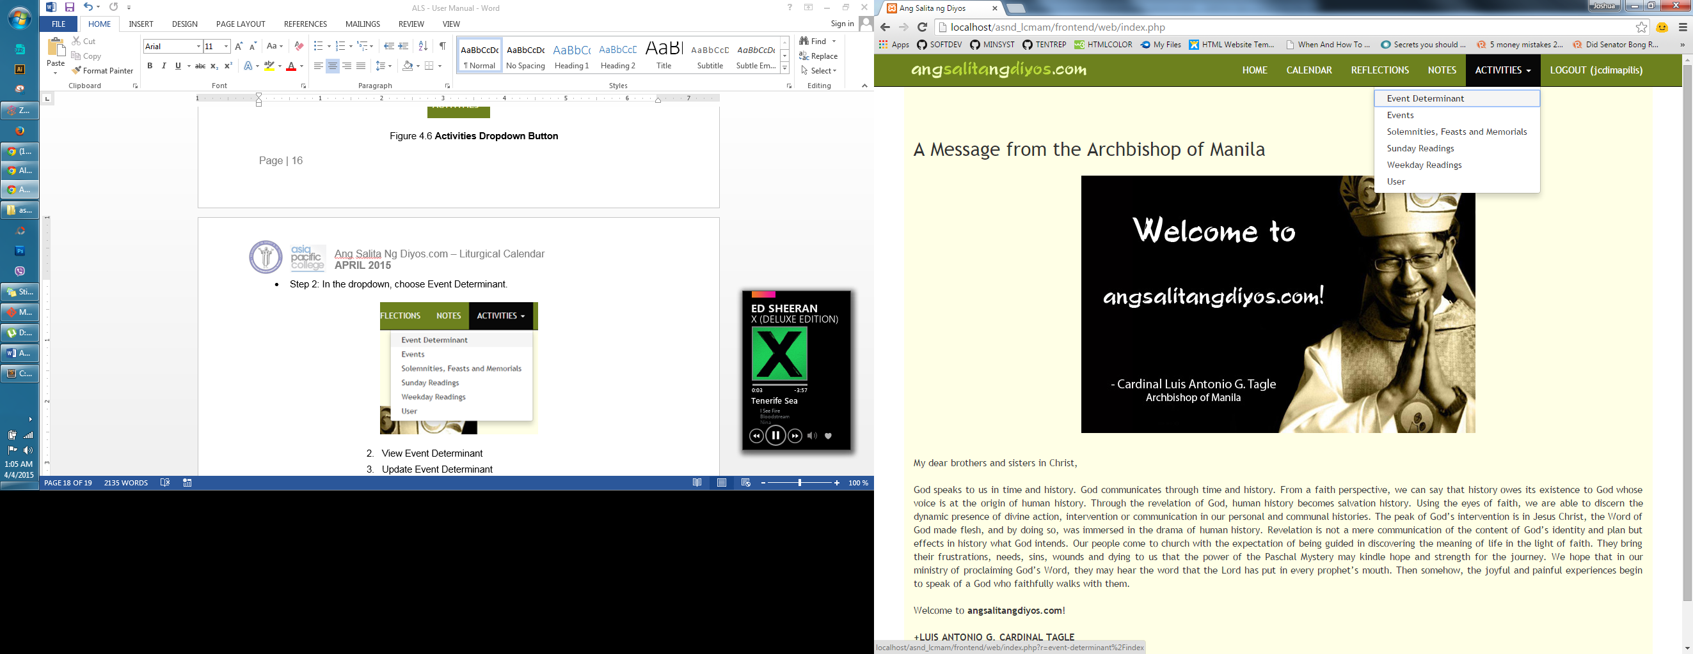

Figure 4.7 **Event Determinant**

* Step 3: Clicking the Event Determinant button from the dropdown list will bring the administrator to the Event Determinant Page. ***\*****Admin may use the textboxes for* ***search****.*

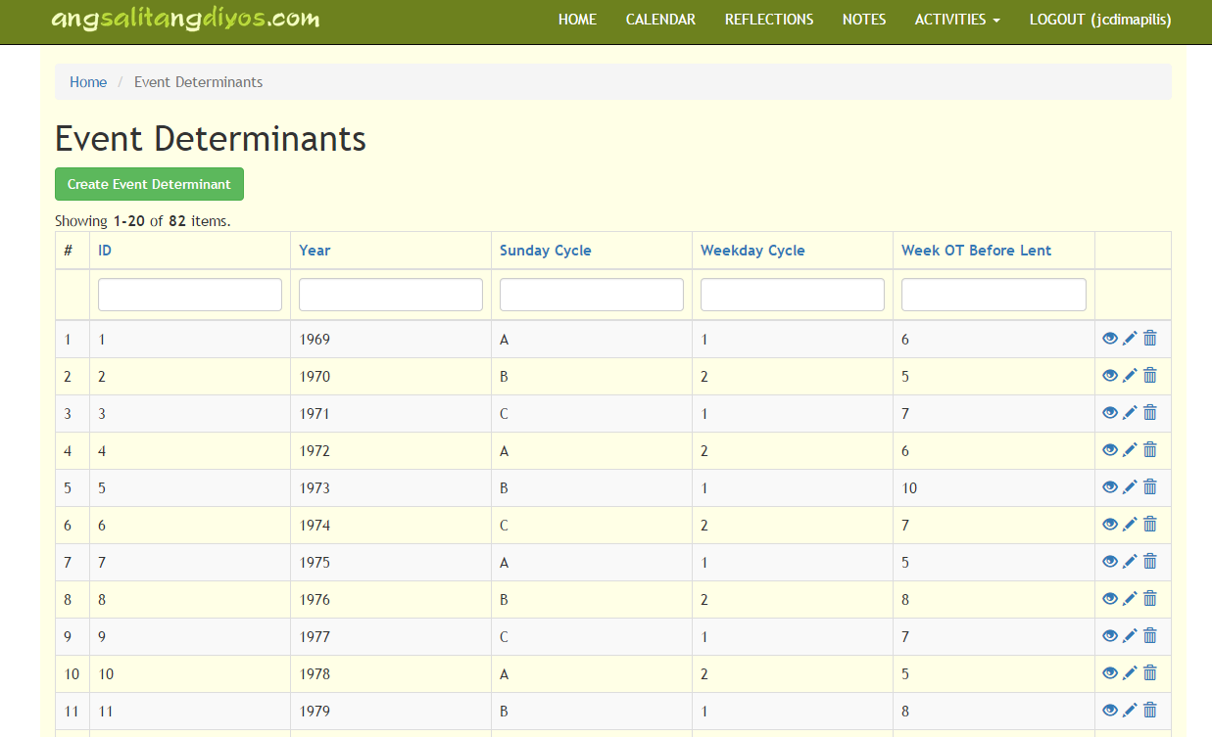

Figure 4.8 **Event Determinants Page**

* Step 4: To create an Event Determinant, admin should click the **Create button.**



Figure 4.9 **Create Event Determinant Button**

Step 5: The button will bring the admin to this form: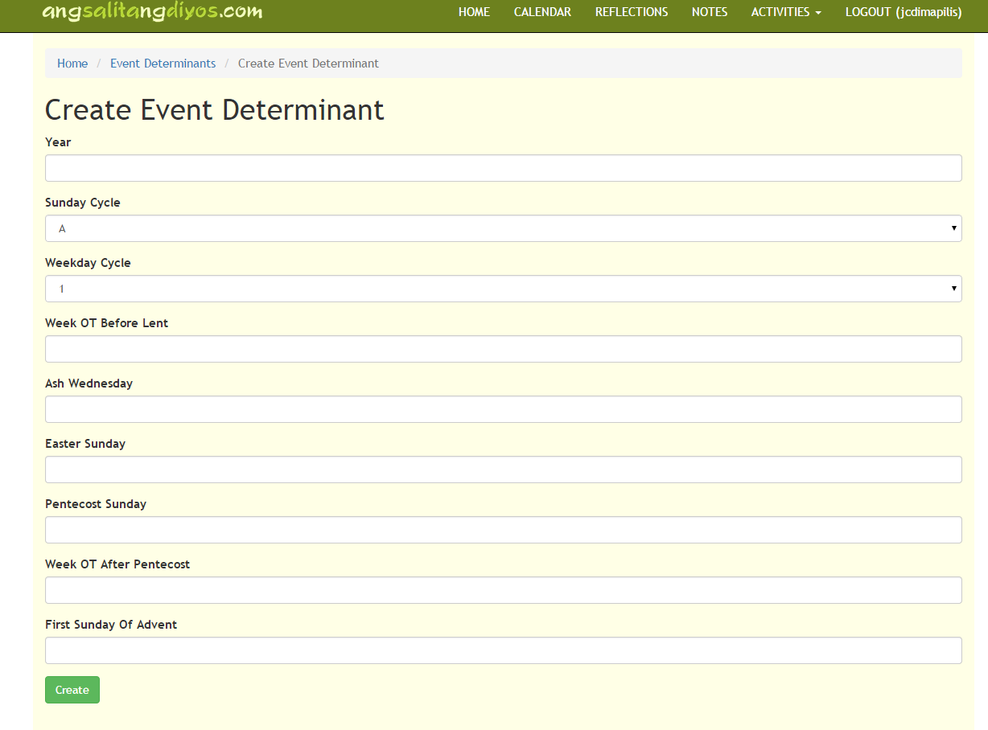 Figure 5.0 **Create Event Determinant Form**

* Step 6: Admin must fill out the text boxes in the said form. It is important to note that if a **year has already been taken**, then it will no longer permit the admin to add another record for that year’s event determinant.

Figure 5.1 **Year Error**

* Step 7: Admin must enter the proper field values for the event determinant, and must specify the proper dates, in the correct format for the calendar to work. This due diligence is of great importance, because upon creating an event determinant, it means that no record for that year has been entered in the past. **Also, it is recommended that the admin should not create event determinants anymore, as the event determinants up to the year 2050 have already been entered.** However, for the sake of sampling and clarity, the sample accomplished form is listed below:

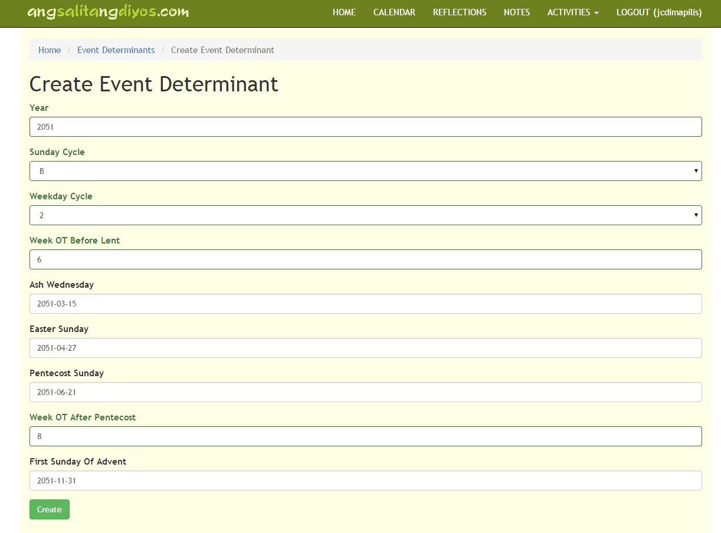

Figure 5.2 **Accomplished** **Create Event Determinant Form**

* Step 8: After this, a record for viewing is created for the admin, listing all the pertinent data that was entered earlier.

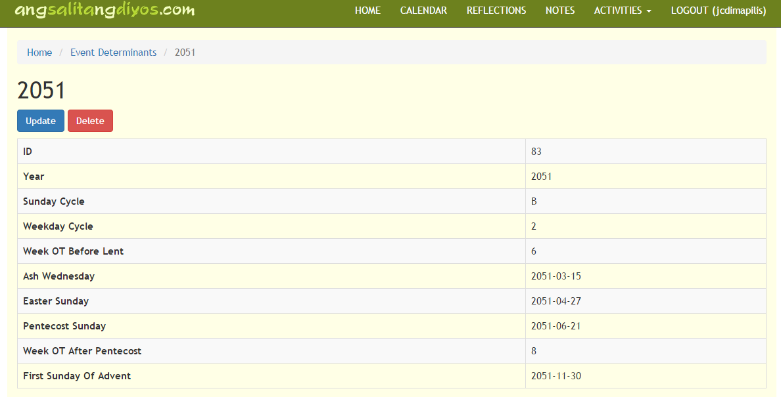

Figure 5.3 **View for Created Event Determinant**

* **NOTE:** The following symbols / icons represent buttons to a certain **RUD** function:



Figure 5.4 **View (Read), Update and Delete Icons**

* The **eye icon** lets you view the individual record, together with its attributes.
* The **pen icon** lets you update the corresponding record and its attributes.
* The **garbage can icon** lets you delete the corresponding record and all attributes that accompany it.

The succeeding steps / instructions will no longer instruct the administrator the usage of the previously mentioned icons, instead, the following sections will discuss how to update and delete after viewing records.

* + - * View Event Determinant
* **NOTE:** The only way to arrive in the view page of a record aside from clicking the eye button is after (creating or updating a certain record)

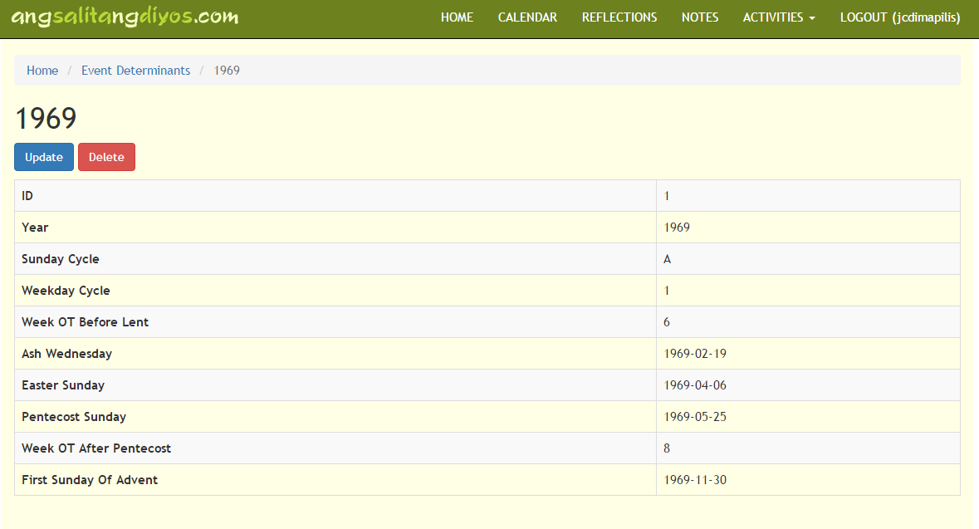

Figure 5.5 **View (Read)** page for the individual record of **Event Determinant** 1969

* + - * Update Event Determinant
* **NOTE:** To arrive at the Update form, user will either have to click the **pen icon,** at the Event Determinant Page, or the **Update Button,** in the individual record’s view page**.**



Figure 5.6 **Update Button**

* Step: After clicking the Update button, the admin is redirected to the record’s update page, which can be seen below. After clicking the Update button in the form, the admin will be redirected back to the view page of the individual record.

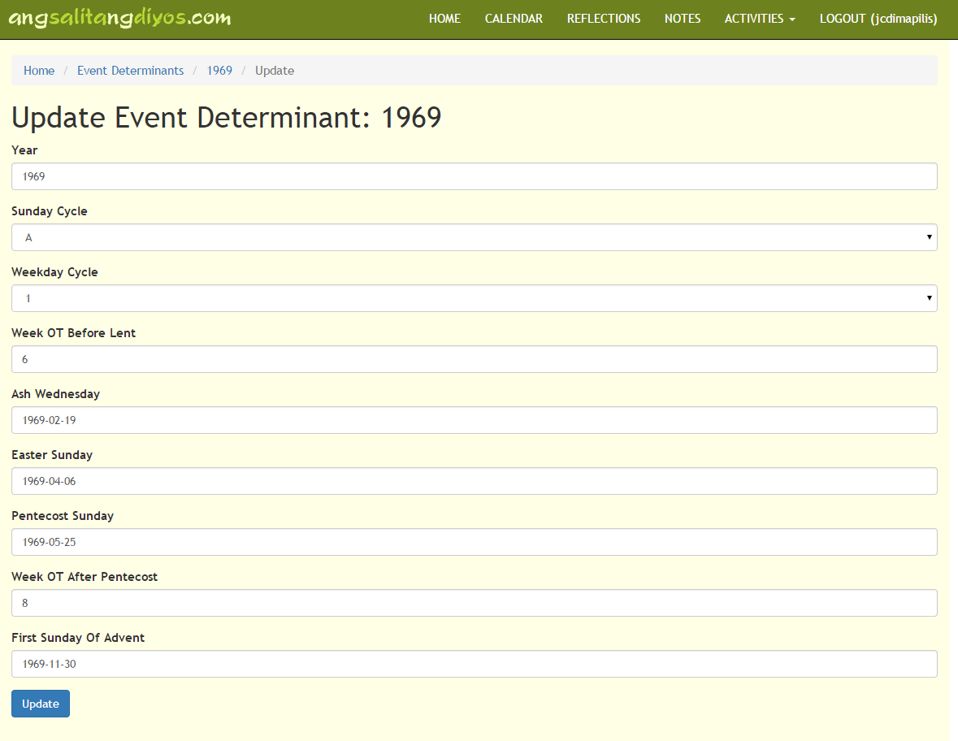

Figure 5.7 **Update Event Determinant Page**

* + - * Delete Event Determinant
* **NOTE:** To delete an event determinant record, user will either have to click the **trash / garbage can icon,** at the Event Determinant Page, or the **Delete Button,** in the individual record’s view page**.**



Figure 5.8 **Delete Button**

* Step: After clicking the delete button, the admin will be prompted if he/she really wants to delete the said record, clicking ok will remove the record from the database, this will redirect the user back to the Event Determinant page.

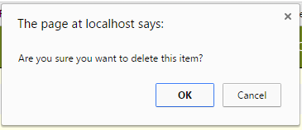

Figure 5.9 **Delete Prompt**

* + 1. Events

The Events table mostly contain Christmas and Advent celebrations that have specific dates that correspond to their position in the calendar.

* Step 1: For admin to be able to see the **Events Page,** admin must select the Event button from the Activities Dropdown

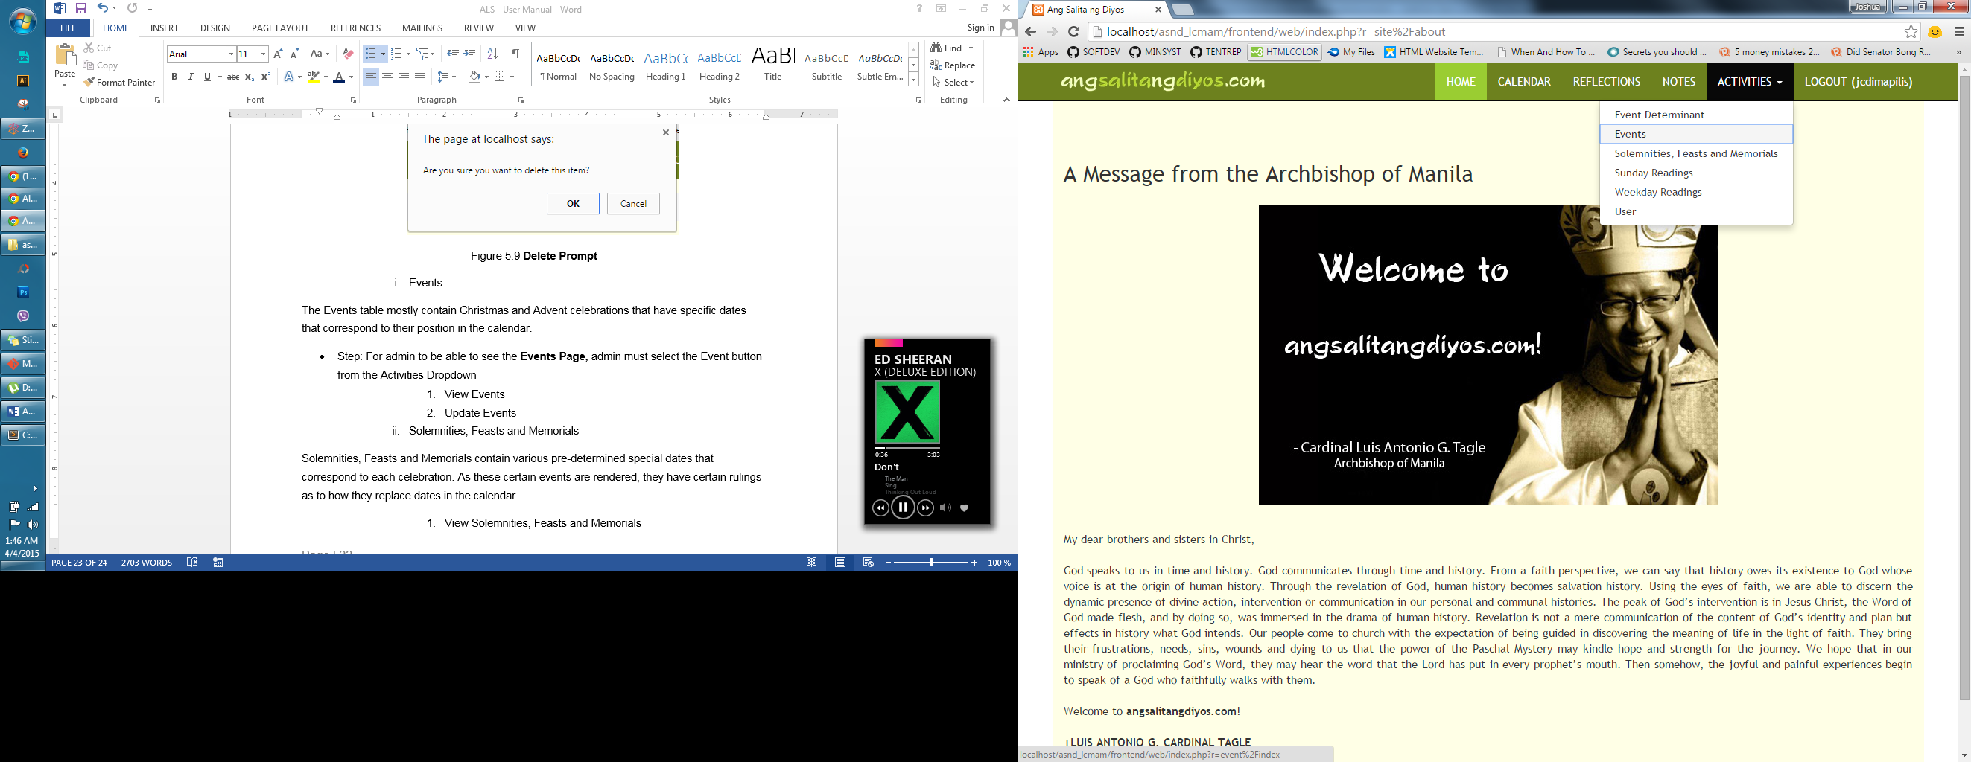

Figure 6.0 **Events**

* Step 2: Admin will be redirected to the Events Page in the image below. ***\*****Admin may use the textboxes for* ***searching****.*

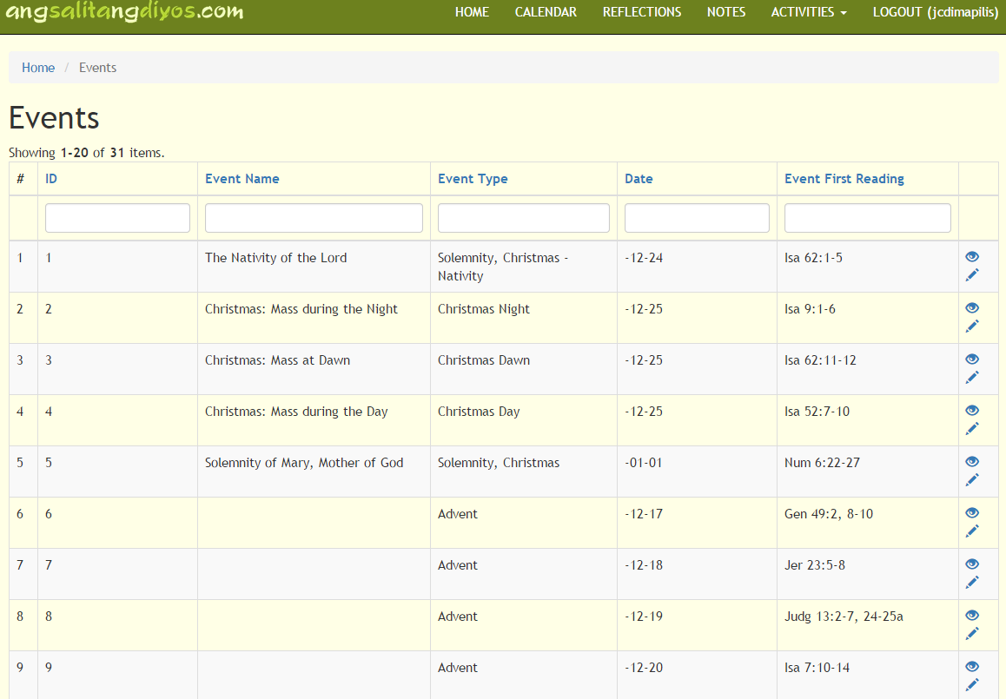

Figure 6.1 **Events Page**

* + - * View Events
* Step: Similar to Event Determinant’s page. Clicking the eye icon, brings you to the individual record’s view page.

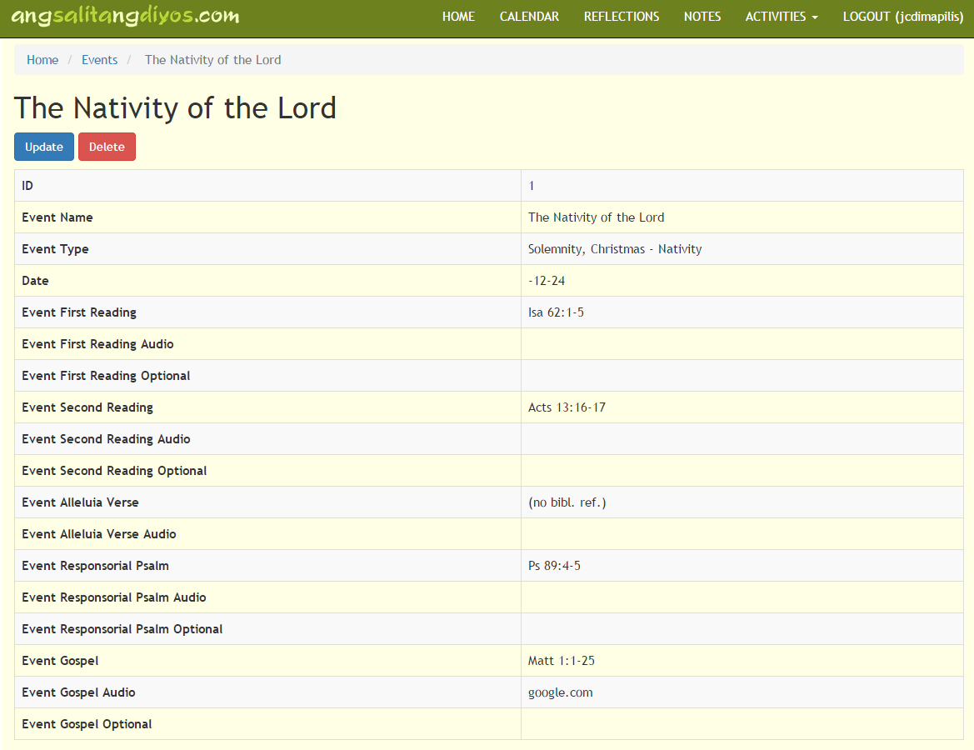

Figure 6.2 **Events View Page for** *Nativity of the Lord*

* + - * Update Events
* Step 1: Clicking the Update button brings you to the event’s update page (as seen in the next image), submitting your updates/changes will redirect you back to the Events page.

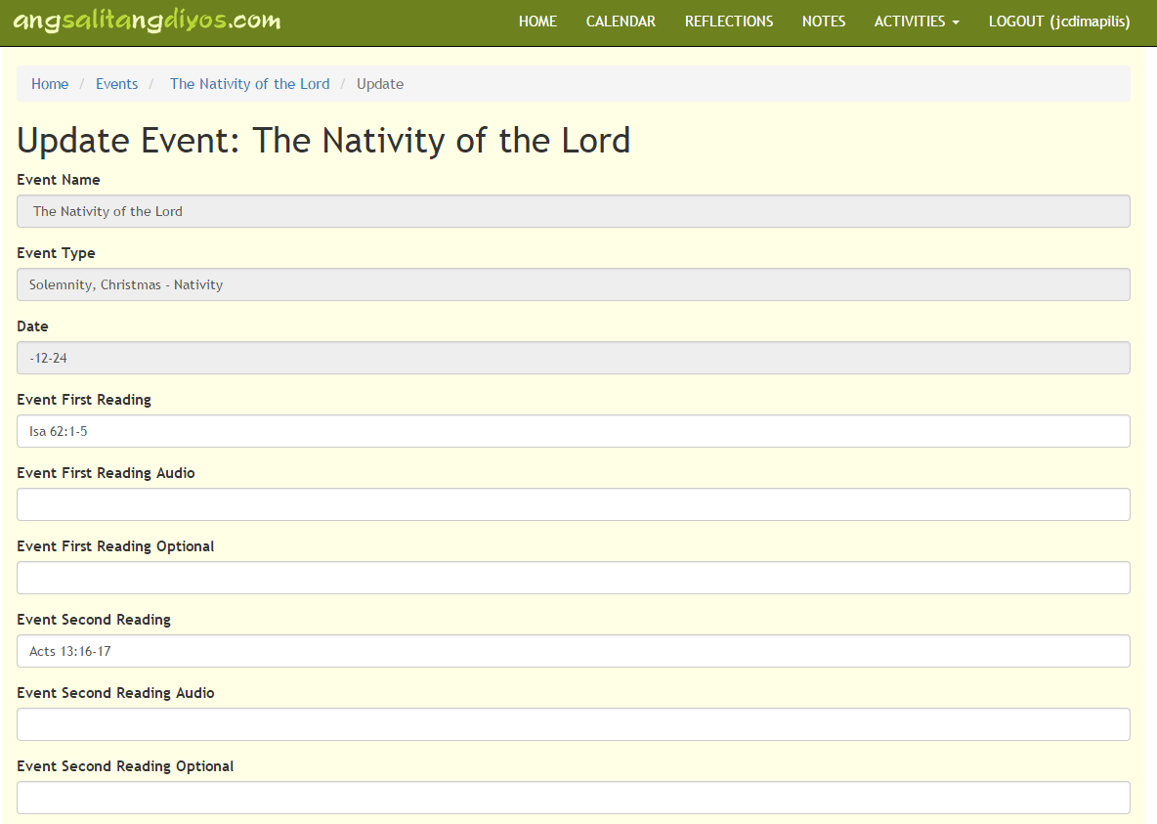

Figure 6.3 **Events Update Page for** *Nativity of the Lord*

**NOTE:** Some textboxes are blocked, because some of these are used as filtering items for *if statements* in the program’s logic / code. However, if in the event that certain items need to be edited, and are blocked – admin may edit database directly (through *phpmyadmin*). However, it is **imperative, to make sure that changes will not affect the plotting of events in the calendar.** Also, clicking the **delete** **button** in this section, will yield an error (so as to not mess up the sequencing and plotting of events):

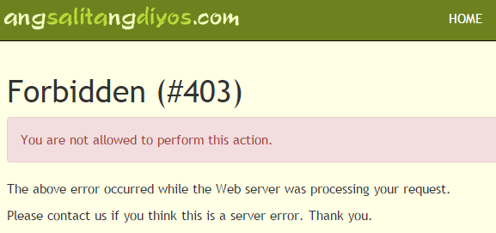

Figure 6.4 **Error upon Deleting Events**

* + 1. Solemnities, Feasts and Memorials

Solemnities, Feasts and Memorials contain various pre-determined special dates that correspond to each celebration. As these certain events are rendered, they have certain rulings as to how they replace dates in the calendar.

* Step 1: For admin to be able to see the **Solemnities, Feasts and Memorials Page (SFMs),** admin must select the SFMs button from the Activities Dropdown

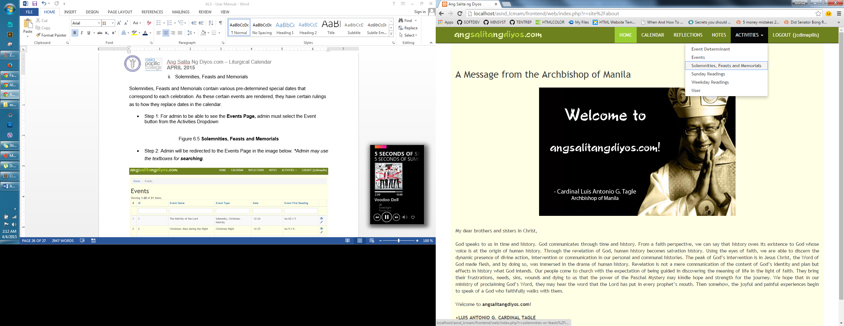

Figure 6.5 **Solemnities, Feasts and Memorials (SFMs)**

* Step 2: Admin will be redirected to the Events Page in the image below. ***\*****Admin may use the textboxes for* ***searching****.*

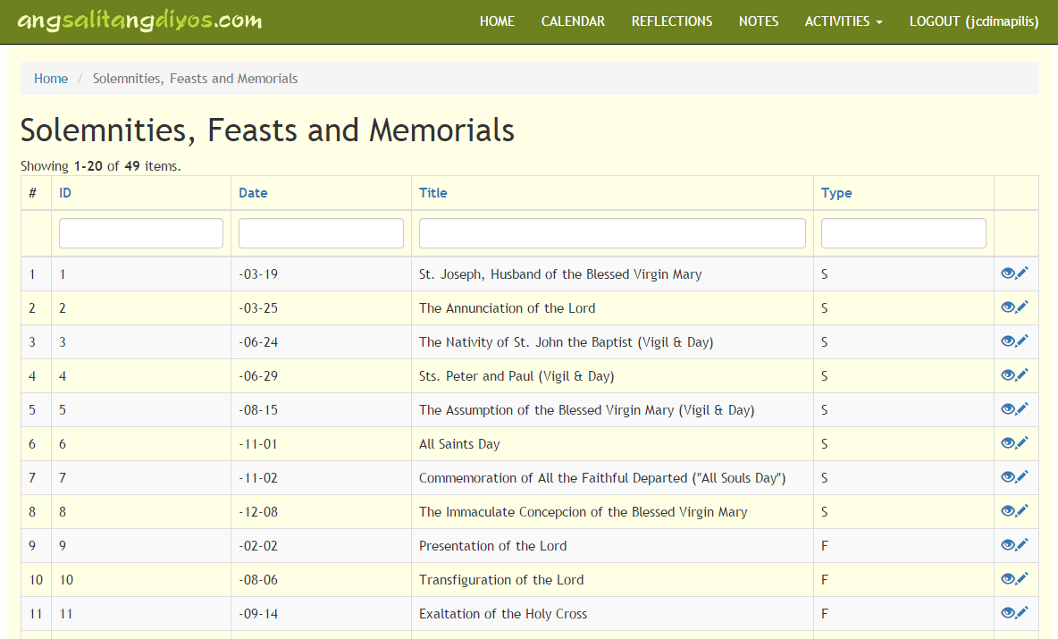

Figure 6.6 **SFMs Page**

* + - * View Solemnities, Feasts and Memorials
* Step: Similar to Event Determinant’s page. Clicking the eye icon, brings you to the individual record’s view page.

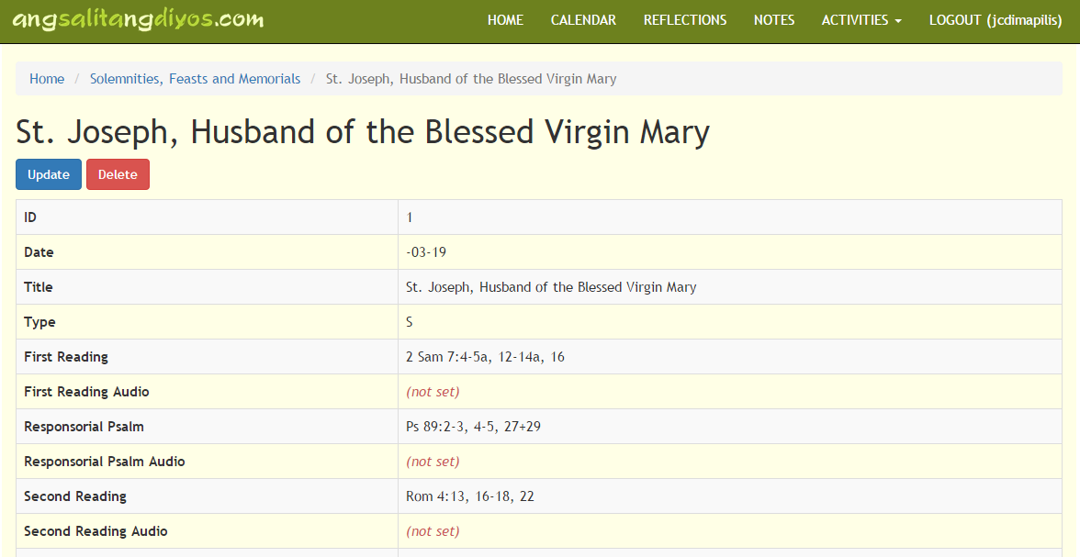

Figure 6.7 **SFMs View Page for** *St. Joseph, Husband of the Blessed Virgin Mary*

* + - * Update Solemnities, Feasts and Memorials
* Step 1: Clicking the Update button brings you to the event’s update page (as seen in the next image), submitting your updates/changes will redirect you back to the SFMs page.

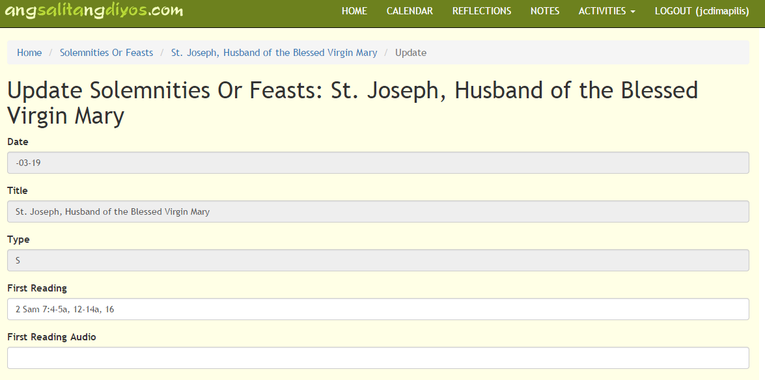

Figure 6.8 **SFMs Update Page for** *St. Joseph, Husband of the Blessed Virgin Mary*

**NOTE:** Similar to the Events entity, some textboxes are blocked, because some of these are used as filtering items for *if statements* in the program’s logic / code.In the event that certain items need to be edited, and are blocked – admin may edit database directly (through *phpmyadmin*). However, it is **imperative, to make sure that changes will not affect the plotting of events in the calendar.** Also, clicking the **delete** **button** in the succeeding sections, will yield an error (so as to not mess up the sequencing and plotting of events):



Figure 6.9 **Error upon Deleting Events**

* + 1. Sunday and Weekday Readings

Sunday and Weekday Readings include various readings that are rendered in the calendar. The various readings are not defined by specific dates, instead, these dates are governed by the rules of Ordinary Time, Lent, Easter, and Advent (as defined in the Event Determinant, and in the program’s logic / code).

* Step 1: For admin to be able to see the **Sunday / Weekday Readings,** admin must select the Sunday / Weekday Readings’ buttons from the Activities Dropdown

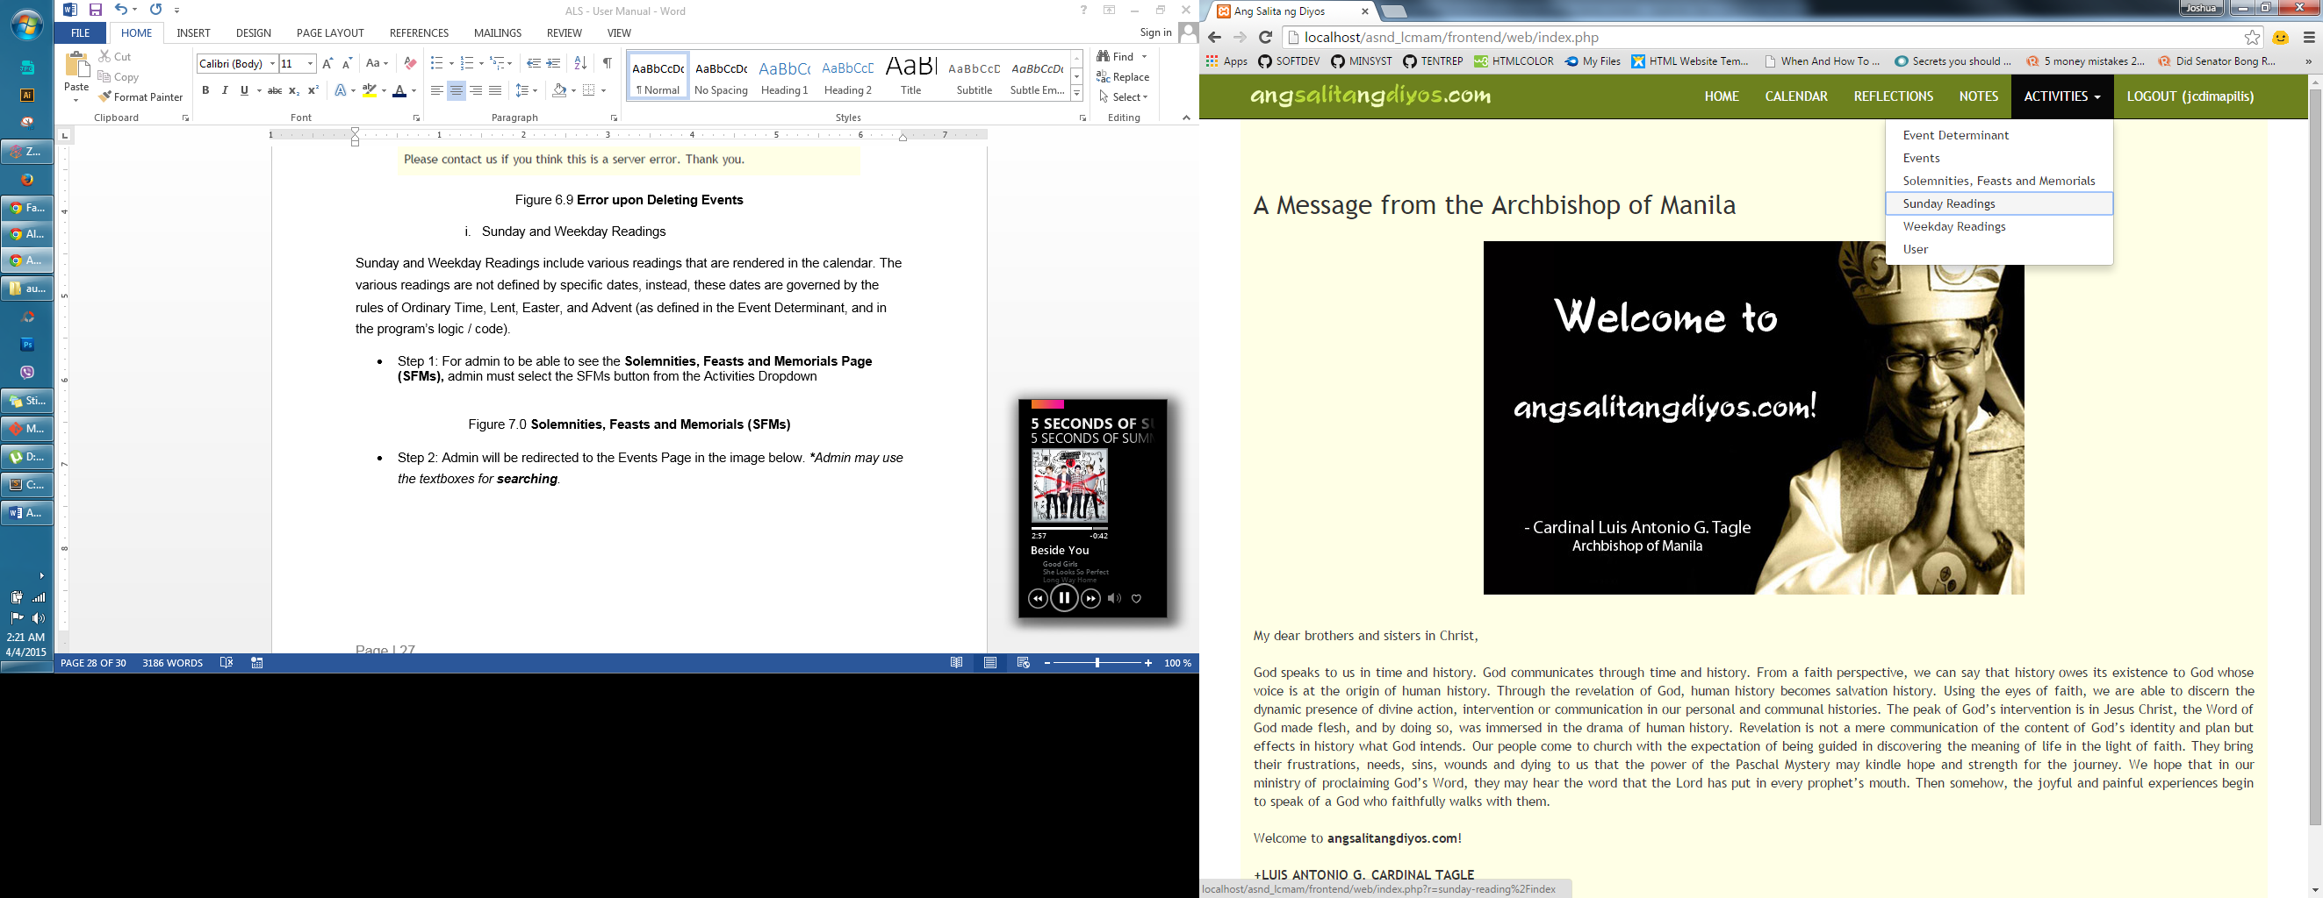 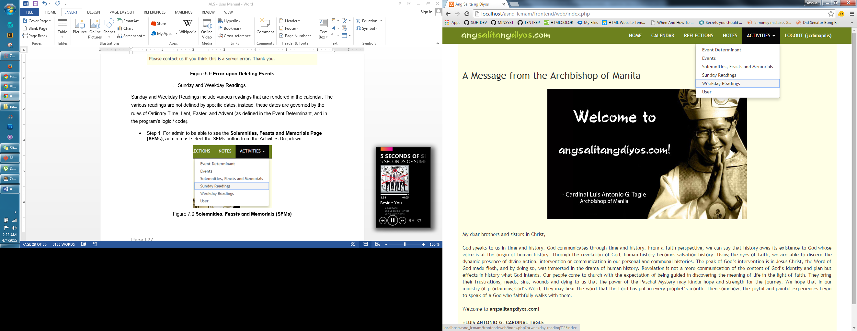

Figure 7.0 **Sunday and Weekday Readings**

* Step 2: Admin will be redirected to the Sunday / Weekday Readings’ Page in the images below. ***\*****Admin may use the textboxes for* ***searching****.*

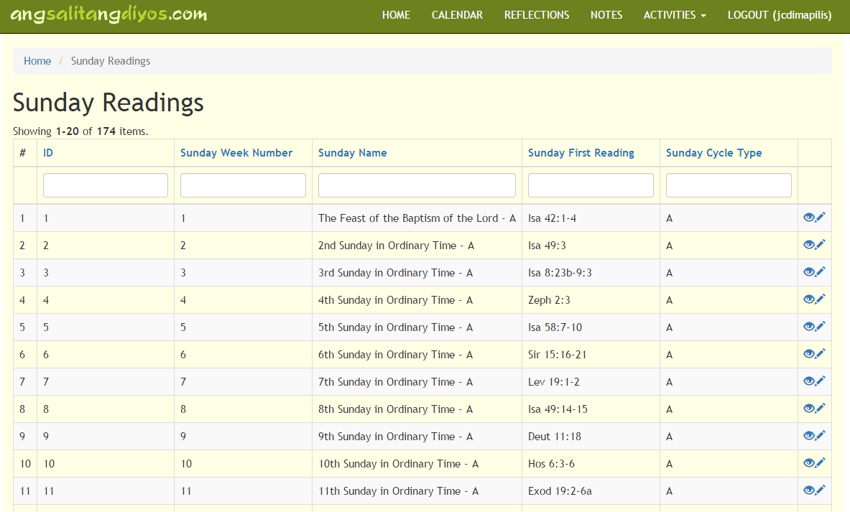

Figure 7.1 **Sunday Readings Page**

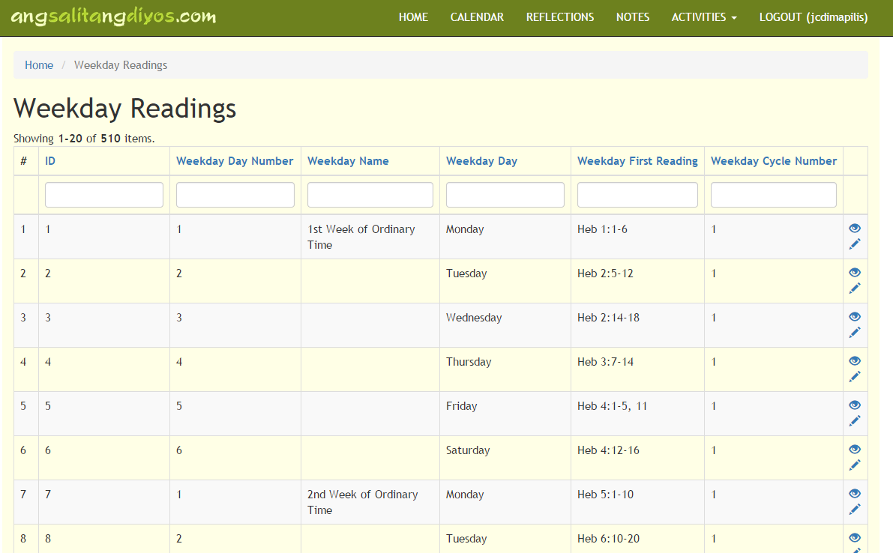

Figure 7.2 **Weekday Readings Page**

* + - * View Readings
* Step: Similar to previous view pages, clicking the eye icon, brings you to the individual record’s view page.

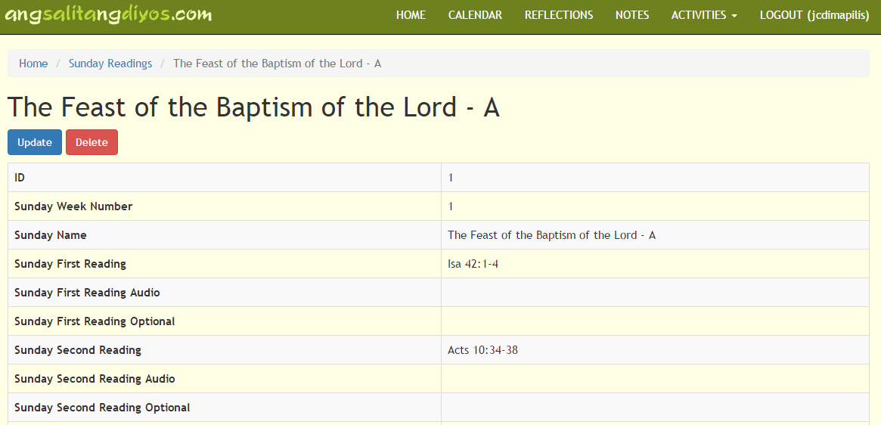

Figure 7.3 **Sunday Reading’s View Page for** *The Feast of the Baptism of the Lord – A*

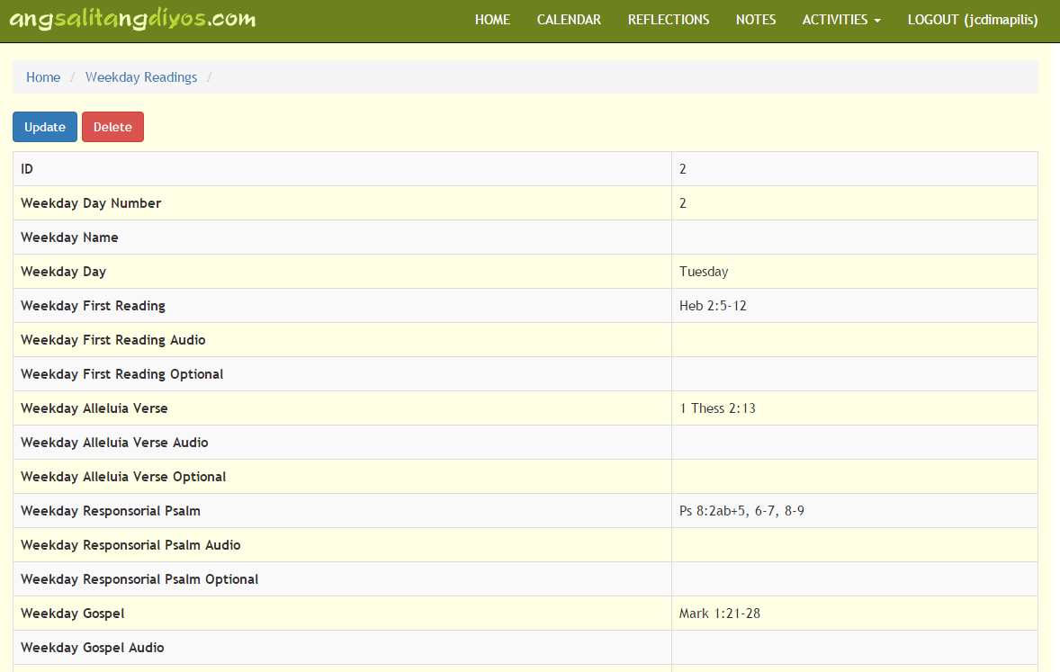

Figure 7.3 **Weekday Reading’s View Page for** *2nd Day in the 1st Week of Ordinary Time (1)*

**NOTE:** There are items that do not have headers, specifically because adding names to the said record would yield in multiple headers for one week in the calendar.

Since most of the two readings’ (Sunday and Weekday) attributes are almost the same, we will be using the Weekday Readings’ update screens to discuss how the updating process is to be performed.

* + - * Update Readings
* Step 1: Clicking the Update button brings you to the event’s update page (as seen in the next image), submitting your updates/changes will redirect you back to the SFMs page.

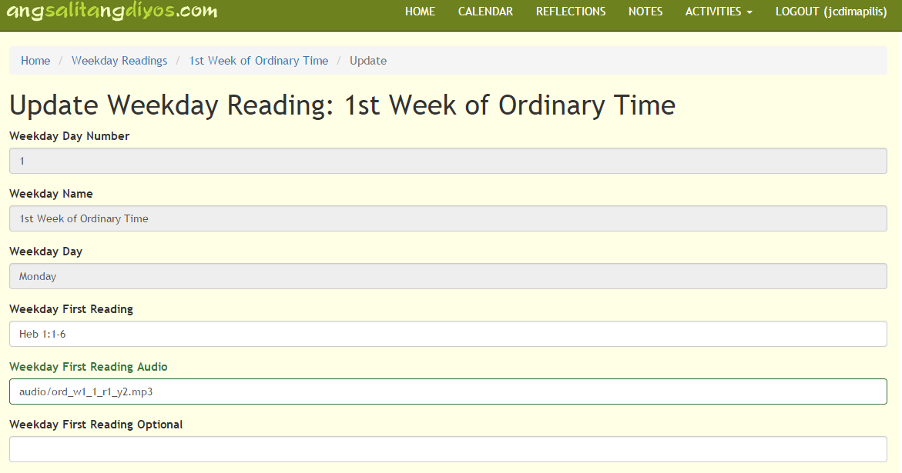

Figure 7.4 **Weekday Reading’s Update Page for** *1st Day in the 1st Week of Ordinary Time (1)*

**NOTE:** As can be seen in the example, the Weekday First Reading Audio shows the value: ***audio/ord_w1_1_r1_y2.mp3.*** This means that inside the test folder where *testCalendar.php* is located, there is another folder named **audio.** Inside this folder, is the mp3 file referenced in the first reading audio. The system uses the manual referencing of links and the usage of: “**../../**”, may be applied for files / pages that are located locally, but are outside the **test** folder. For external links, the admin may replace the value with: “http://samplelink.com”, in the textbox for the first reading audio. The exact location that it considers as ‘home’ is inside **ALSCalendarForHost/calendar/test** or **ALSCalendar/calendar/test.** Admin may choose to place folders inside or outside the links, but location must be definite for links to work.

* + 1. Users

The users section only allows views, as it is only for confirmation / verification purposes for the admin to those who already have accounts in the system.

* Step 1: For admin to be able to see the **Users,** admin must select the User button from the Activities Dropdown

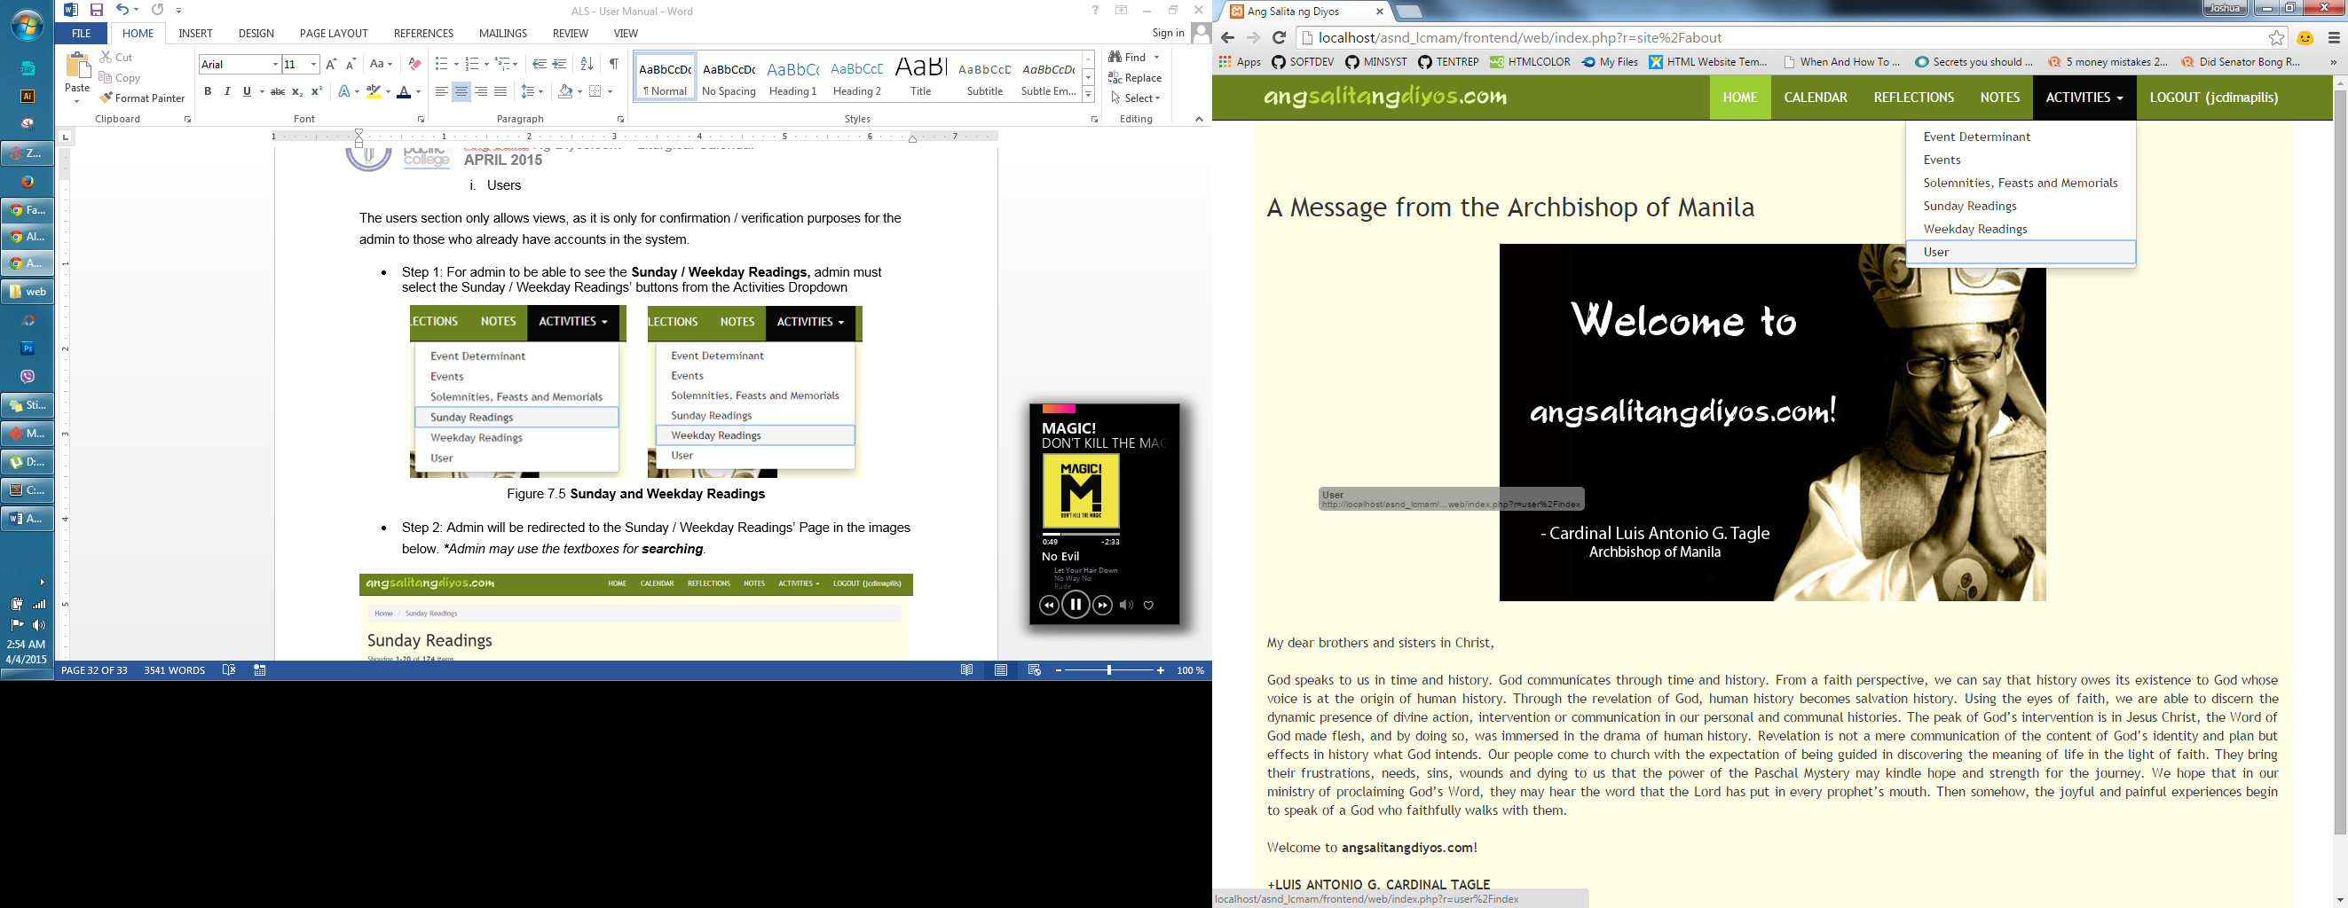

Figure 7.5 **User**

* Step 2: Admin will be redirected to the User Page in the images below. ***\*****Admin may use the textboxes for* ***searching****.*

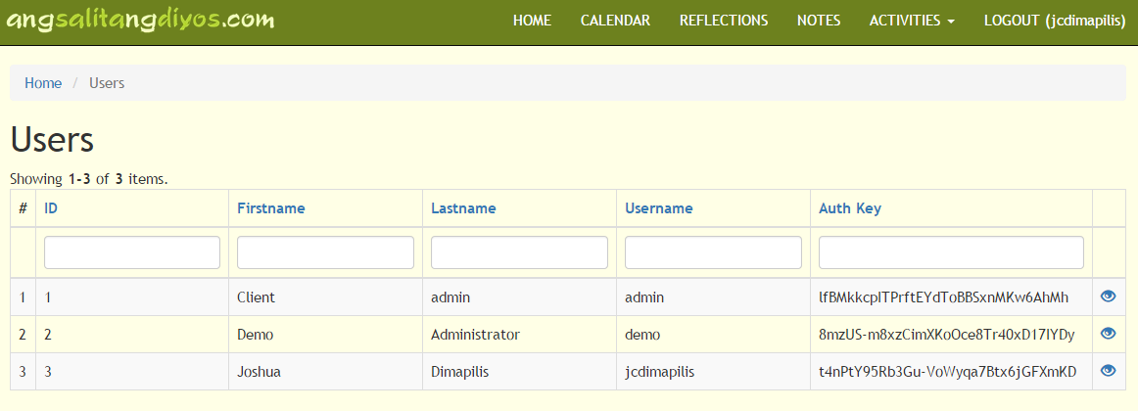

Figure 7.6 **Sunday Readings Page**

* + - * View Users
* Step 1: Similar to previous view pages, clicking the eye icon, brings you to the individual record’s view page, which is represented in the succeeding image.

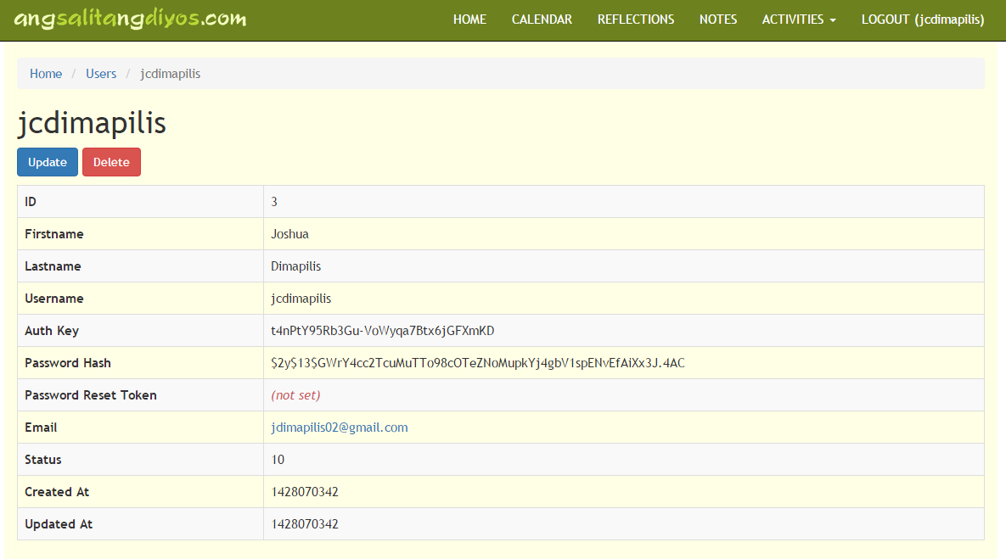

Figure 7.7 **Sunday Reading’s View Page for** *user* jcdimapilis

* Step 2: If admin attempts to update / delete an individual user record, they will be faced with this error, which restricts them from updating / deleting the said records.



Figure 7.8 **Error upon Updating or Deleting Individual User Records**